July 17, 2024

wycliffe kamba

kambaworx TECHNOLOGIES

kambaworxtechnologies@gmail.com

MY SHAMBA

RESOURCE MANAGEMENT SYSTEM

**MY SHAMBA.**

**Resource Management Area.**

**Problems.**

1. Water Management:

Inefficient use of water resources leads to wastage and scarcity during dry seasons.

1. Soil Health Monitoring.

Lack of regular soil health assessments results in overuse or underuse of fertilizers, affecting crop yield.

1. Fertilizer and Pesticide Management:

Overuse of fertilizers and pesticides leads to soil degradation and environmental pollution.

1. Data Accessibility and Usage:

Farmers lack access to real-time data on resource usage and soil conditions.

**Solutions.**

1. Water Management:

Implement smart irrigation system that monitors soil moisture and weather conditions to optimize water usage.

1. Soil Health Monitoring:

Deploy IoT sensors for continuous monitoring of soil moisture, temperature and nutrients level and provide actionable insights to farmers.

1. Fertilizer and Pesticide Management:

Provide data-driven recommendations on the optimal use of fertilizers and pesticides based on soil health data.

1. Data Accessibility and Usage:

Develop a mobile and web application that offers real-time updates and personalized recommendations based on collected data.

**Scope of the resource management system**.

1. Core functions:

* Monitor soil health (moisture, temperature, nutrients levels).
* Track and manage water, fertilizer and pesticide usage.
* Provide recommendations for optimal resource usage.
* Deliver real-time data and alerts to farmers.

1. User roles:

* **Farmers**: Access resource data and recommendations.
* **System Administrators**: Manage and maintain the resource management system.
* **Agricultural Experts**: Analyze data and provide recommendations.
* **Policy Makers**: Use aggregated data for regional planning and policy development.

**Conceptual Modeling**.

**Brain storming session:**

* Farms in different locations.
* Farmers owning farms.
* Soil data including moisture, temperature and nutrients level.
* Water usage tracking for different farms.
* Types of fertilizers used by a farmer.
* Types of pesticides used by a farmer.
* Crop yield data for various crops.

**Processes:**

**Identifying the entities**

1. Farms
2. Farmer
3. Location
4. Soil Data
5. Water Usage
6. Fertilizer Usage
7. Crops
8. Harvest
9. Pesticide Usage

**Identifying their relationships**

1. **Farm**

* A farm is located in one place.
* A farm can belong to one or many farmers.
* A farm can have one or many soil data entries.
* A farm can have one or many crops.
* A farm can have one or many harvests.
* A farm can have one or many water usage records.
* A farm can use one or many fertilizers.

1. **Farmer**

* A farmer can own one or many farms.
* A farmer can plant one or many crops.
* A farmer can use one or many fertilizers.

1. **Location**

* A location can contain one or many farms.

1. **Soil Data**

* Several soil data entries can belong to one farm.

1. **Water Usage**

* Several water usage records can belong to one farm.

1. **Fertilizer**

* A fertilizer can be used by one or many farms.

1. **Crop**

* A crop can be grown on one or many farms.
* A crop can be treated with one or many pesticides.

1. **Harvest**

* A harvest is associated with one or many farms.
* A harvest can be associated one or many crops.

1. **Pesticide**

* A pesticide can be used on many crops.

**Conceptual Model.**

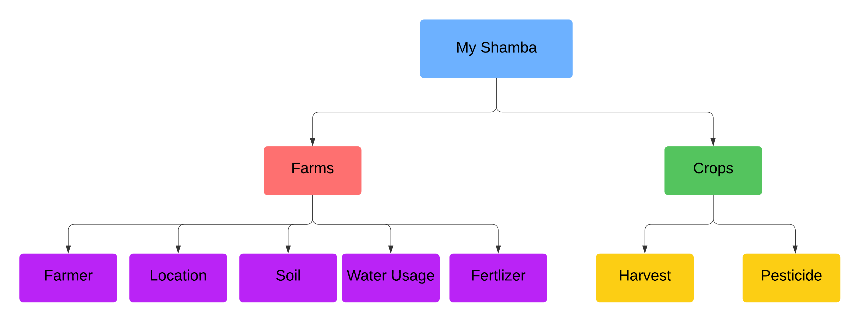

* Identified the main concepts and the sub-concepts.

**Logical Model.**

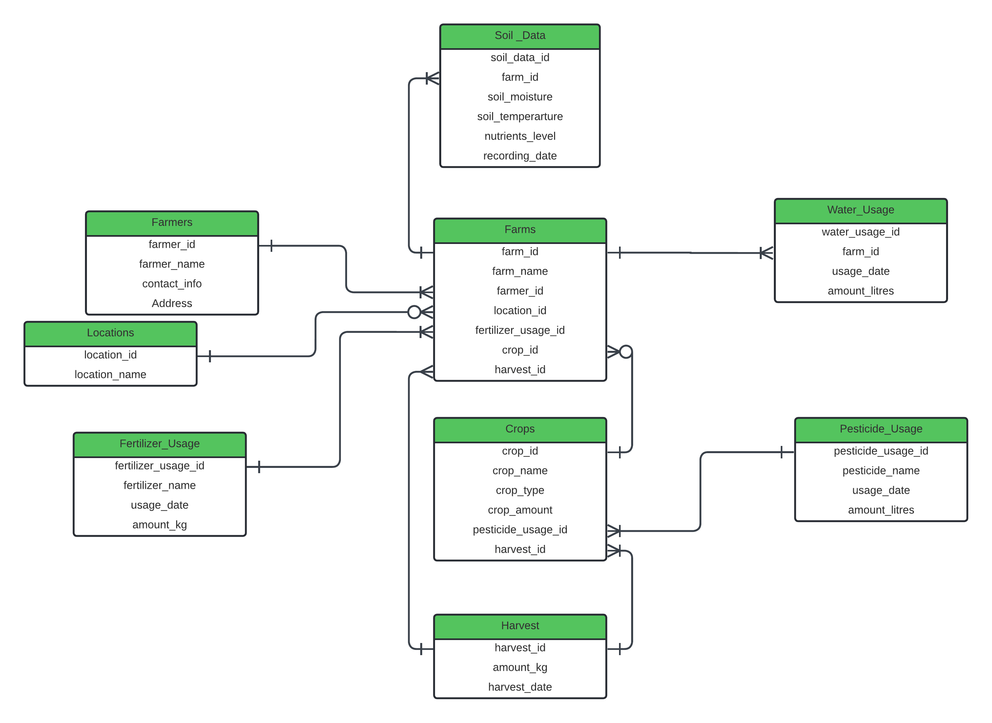

Identified the entities’ attributes:

1. **Farms**

Farm_id(pk)

Farm_name

Location_id(fk)

Fertilizer_usage_id(fk)

Crop_id(fk)

Harvest_id(fk)

1. **Farmer**

Farmer_id(pk)

Farmer_name

Contact_info

Address

1. **Location**

Location_id(pk)

Location_name

1. **Soil Data**

Soil_data_id(pk)

Farm_id(fk)

Soil_moisture

Soil_temperature

Nutrients_level

Recording_date

1. **Water Usage**

Water_usage_id(pk)

Farm_id(pk)

Usage_date

Amount_litres

1. **Fertilizer**

Fertilizer_usage_id(pk)

Fertilizer_name

Usage_date

Amount_kg

1. **Crops**

Crop_id(pk)

Crop_name

Crop_type

Crop_amount

Pesticide_usage_id

Harvest_id

1. **Harvest**

Harvest_id(pk)

Amount_kg

Harvest_date

1. **Pesticide**

Pesticide_usage_id(pk)

Pesticide_name

Amount_litres

Usage_date

**Physical Model.**

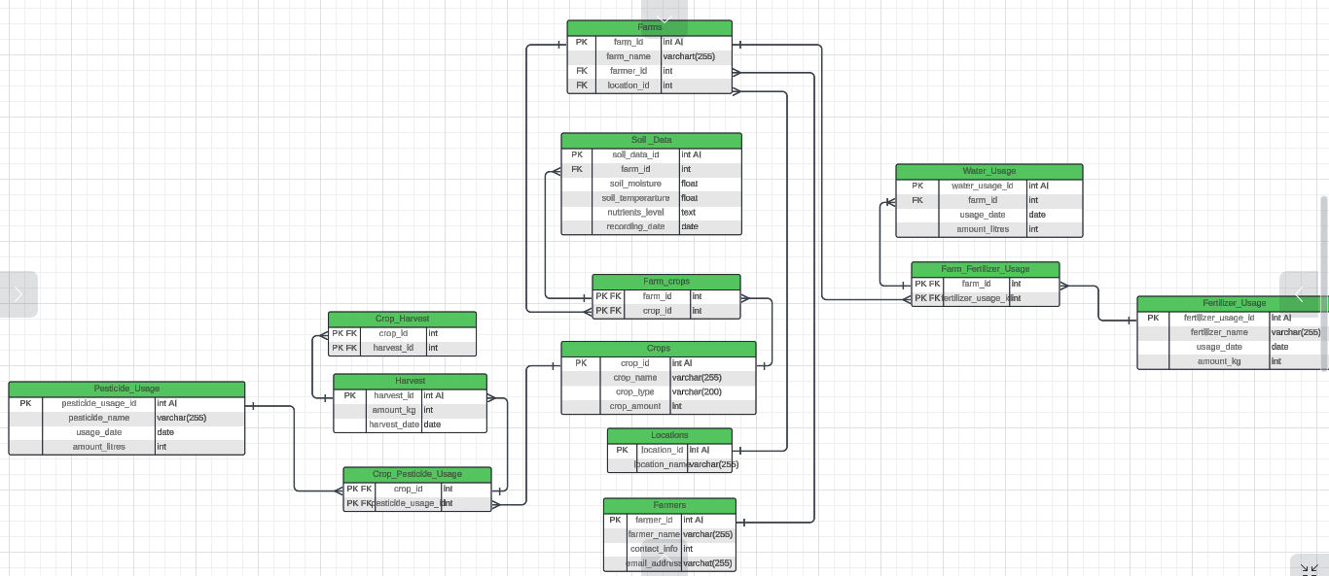

* Defined attribute’s specific data types.
* Identified many to many relationships and implemented junction tables.

They include:

1. Farm_Fertilizer_Usage
2. Farm_Crops
3. Crop_Pesticide_Usage
4. Crop_Harvest

Their relationships with the other tables:

1. A farm can use multiple types of fertilizer, and a single type of fertilizer can be used on multiple farms.
2. A farm can grow multiple crops, and a single type of crop can be grown on multiple farms.
3. A crop can be treated with multiple pesticides, and a pesticide can be used on multiple crops.
4. A crop can have multiple harvests, and a harvest can consist of multiple crops.

* Created database constraints, indices, triggers and other database specific objects.

Below are the SQL queries for creating the database schema:

-- Created farmers table and added its attributes

**CREATE** **TABLE** farmers (

farmer_id **INTEGER** **PRIMARY** **KEY** **AUTOINCREMENT**,

farmer_name **VARCHAR**(255) **NOT** **NULL**,

contact_info **INTEGER** **NOT** **NULL**,

email_address **VARCHAR**(255)

);

-- Created locations table and added its attributes

**CREATE** **TABLE** locations (

location_id **INTEGER** **PRIMARY** **KEY** **AUTOINCREMENT**,

location_name **VARCHAR**(255) **NOT** **NULL**

);

-- Created farms table and added its attributes

**CREATE** **TABLE** farms (

farm_id **INTEGER** **PRIMARY** **KEY** **AUTOINCREMENT**,

farm_name **VARCHAR**(255) **NOT** **NULL**,

farmer_id **INTEGER**,

location_id **INTEGER**,

**FOREIGN** **KEY** (farmer_id) **REFERENCES** farmers(farmer_id),

**FOREIGN** **KEY** (location_id) **REFERENCES** locations(location_id)

);

-- Created crops table and added its attributes

**CREATE** **TABLE** crops (

crop_id **INTEGER** **PRIMARY** **KEY** **AUTOINCREMENT**,

crop_name **VARCHAR**(255) **NOT** **NULL**,

crop_type **VARCHAR**(200) **NOT** **NULL**,

crop_amount **INTEGER**

);

-- Created Soil_Data table and added its attributes

**CREATE** **TABLE** soil_data (

soil_data_id **INTEGER** **PRIMARY** **KEY** **AUTOINCREMENT**,

farm_id **INTEGER**,

soil_moisture **FLOAT**,

soil_temperature **FLOAT**,

nutrients_level **TEXT**,

recording_date **DATE**,

**FOREIGN** **KEY** (farm_id) **REFERENCES** farms(farm_id)

);

-- Created Farm_Crops table and added its attributes

**CREATE** **TABLE** farm_crops (

farm_id **INTEGER**,

crop_id **INTEGER**,

**PRIMARY** **KEY** (farm_id, crop_id),

**FOREIGN** **KEY** (farm_id) **REFERENCES** farms(farm_id),

**FOREIGN** **KEY** (crop_id) **REFERENCES** crops(crop_id)

);

-- Created Water_Usage table and addded its attributes

**CREATE** **TABLE** water_usage (

water_usage_id **INTEGER** **PRIMARY** **KEY** **AUTOINCREMENT**,

farm_id **INTEGER**,

usage_date **DATE**,

amount_litres **INTEGER**,

**FOREIGN** **KEY** (farm_id) **REFERENCES** farms(farm_id)

);

-- Created Harvest table and addded its attributes

**CREATE** **TABLE** harvest (

harvest_id **INTEGER** **PRIMARY** **KEY** **AUTOINCREMENT**,

amount_kg **INTEGER**,

harvest_date **DATE**

);

-- Created Crop_Harvest table and addded its attributes

**CREATE** **TABLE** crop_harvest (

crop_id **INTEGER**,

harvest_id **INTEGER**,

**PRIMARY** **KEY** (crop_id, harvest_id),

**FOREIGN** **KEY** (crop_id) **REFERENCES** crops(crop_id),

**FOREIGN** **KEY** (harvest_id) **REFERENCES** harvest(harvest_id)

);

-- Created Fertilizer_Usage table and addded its attributes

**CREATE** **TABLE** fertilizer_usage (

fertilizer_usage_id **INTEGER** **PRIMARY** **KEY** **AUTOINCREMENT**,

fertilizer_name **VARCHAR**(255) **NOT** **NULL**,

usage_date **DATE**,

amount_kg **INTEGER**

);

-- Created Farm_Fertilizer_Usage table and addded its attributes

**CREATE** **TABLE** farm_fertilizer_usage (

farm_id **INTEGER**,

fertilizer_usage_id **INTEGER**,

**PRIMARY** **KEY** (farm_id, fertilizer_usage_id),

**FOREIGN** **KEY** (farm_id) **REFERENCES** farms(farm_id),

**FOREIGN** **KEY** (fertilizer_usage_id) **REFERENCES** fertilizer_Usage(fertilizer_usage_id)

);

-- Created Pesticide_Usage table and addded its attributes

**CREATE** **TABLE** pesticide_usage (

pesticide_usage_id **INTEGER** **PRIMARY** **KEY** **AUTOINCREMENT**,

pesticide_name **VARCHAR**(255) **NOT** **NULL**,

usage_date **DATE**,

amount_litres **INTEGER**

);

-- Created Crop_Pesticide_Usage table and addded its attributes

**CREATE** **TABLE** crop_pesticide_usage (

crop_id **INTEGER**,

pesticide_usage_id **INTEGER**,

**PRIMARY** **KEY** (crop_id, pesticide_usage_id),

**FOREIGN** **KEY** (crop_id) **REFERENCES** crops(crop_id),

**FOREIGN** **KEY** (pesticide_usage_id) **REFERENCES** pesticide_usage(pesticide_usage_id)

);